**Activity #1**

Cut out the following terms and create a homeostatic feedback loop for the regulation of blood glucose. Once you have had it checked and approved, discuss where and how the two conditions in the grey boxes would impact the feedback loop.

|  |  |  |  |
| --- | --- | --- | --- |
| Homeostasis  Blood glucose level  70-110 mg/100 mL | Blood glucose level rises | Blood glucose level falls | Alpha cells of the pancreas release glucagon |
| Blood glucose level declines | Blood glucose level rises | Skipping a meal | Beta cells of pancreas release insulin |
| Glucose transporters take in more glucose in liver | Glucose converted into glycogen | Eating a meal | Liver breaks down glycogen and releases glucose into the blood |
| Type I Diabetes  (No insulin release) | Epinephrine is released | ------------------------- | ------------------------- |

**ACTIVITY #2**

1. Explain how the binding of insulin controls metabolism inside this cell.
2. What do you think is meant by “protein synthesis”?
   1. *HINT: Think about which proteins might need to be manufactured when insulin binds to this receptor.*
3. Why might you want to inhibit gluconeogenesis under these conditions?
4. Predict the result of a patient who has inherited a mutant copy of the insulin receptor gene.
5. Predict the result of a patient who has acquired an overactive CAP gene.

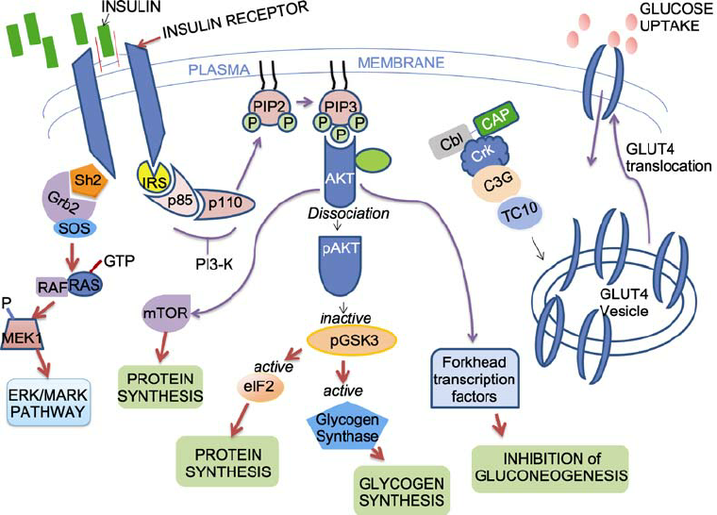

**ACTIVITY #3**

Use the following diagram to compare and contrast the pathways for metabolism of glucose in the liver and muscle cells.

